# Assignment 7B - Linux Firewall (Extra Credit)

|  |
| --- |
| * This is an individual assignment and is worth 10 points. * The due date and time is Tuesday, 1:00 pm (sec01) / 5:30 pm (sec76), November 5. * Apply the usual naming convention. Use the file “Assignment7B-Outcome.docx” for submission. |

## Task 1

1. On the Kali, create a rule that blocks ping requests from the host.
2. Ping the Kali from the host
3. Take a screenshot of the outcome

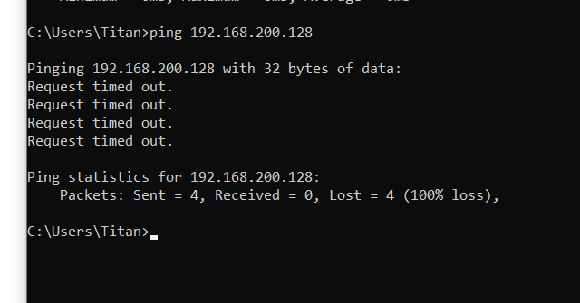

1. Delete all rules in chain or all chains

## Task 2

1. On the Kali, create a rule that blocks ping requests from the Kali.
2. Ping uofl.edu from the Kali
3. Take a screenshot of the outcome

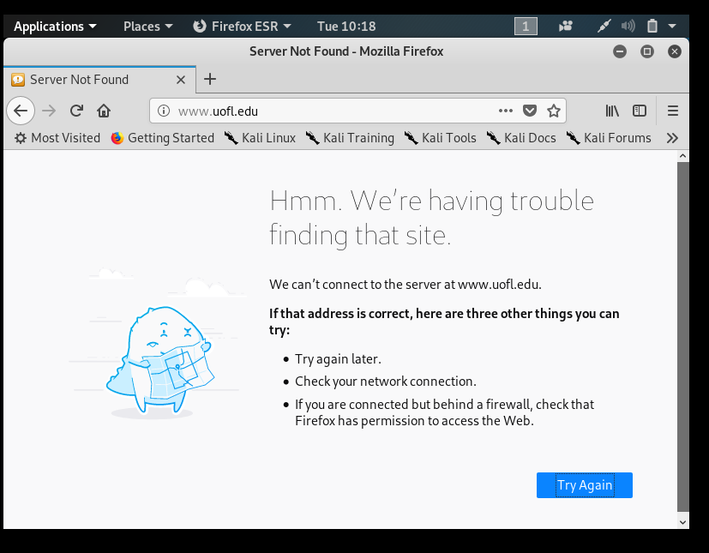

1. Delete all rules in chain or all chains

## Task 3

1. On the Kali, create a rule that blocks DNS requests from the Kali.
2. Go to uofl.edu
3. Take a screenshot of the outcome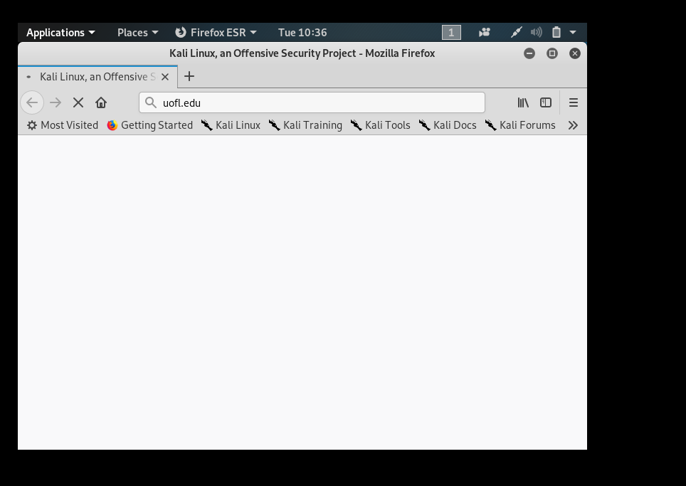
4. Delete all rules in chain or all chains

## Task 4

1. On the Kali, create a rule that blocks http, https requests from the Kali.
2. Go to uofl.edu
3. Take a screenshot of the outcome

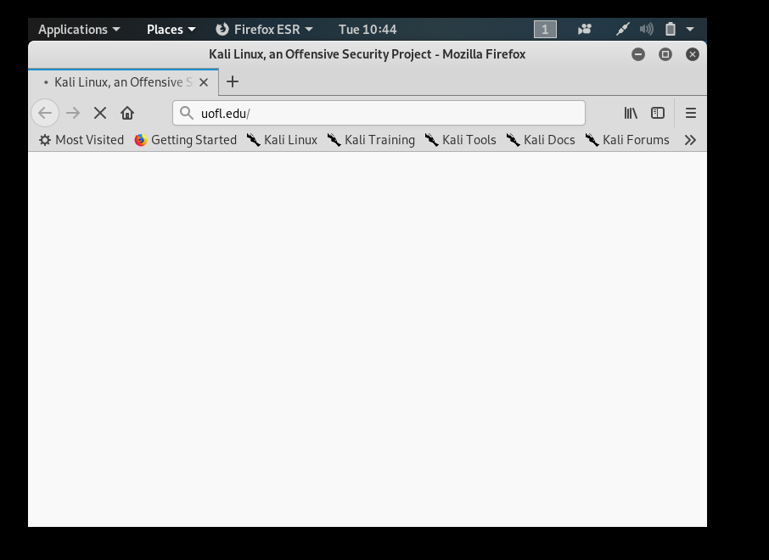

1. Delete all rules in chain or all chain